**Results of Visualization**

**Correlation Heatmap of Employee Burnout Factors**

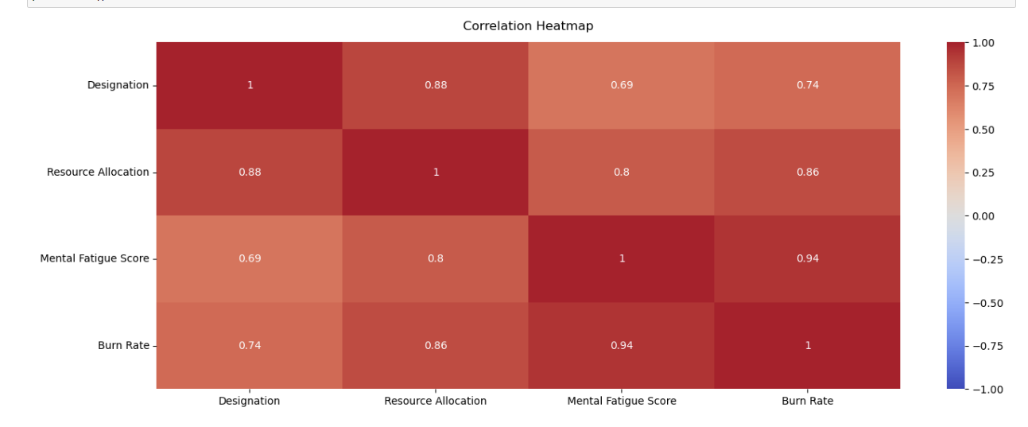

**Correlation between Burn Rate and other numerical dimensions**

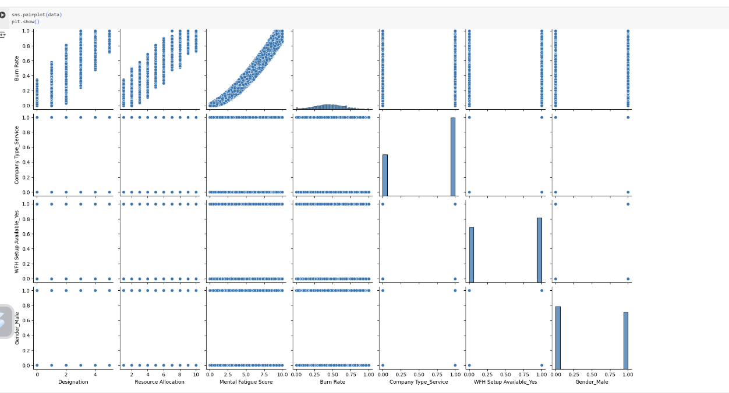

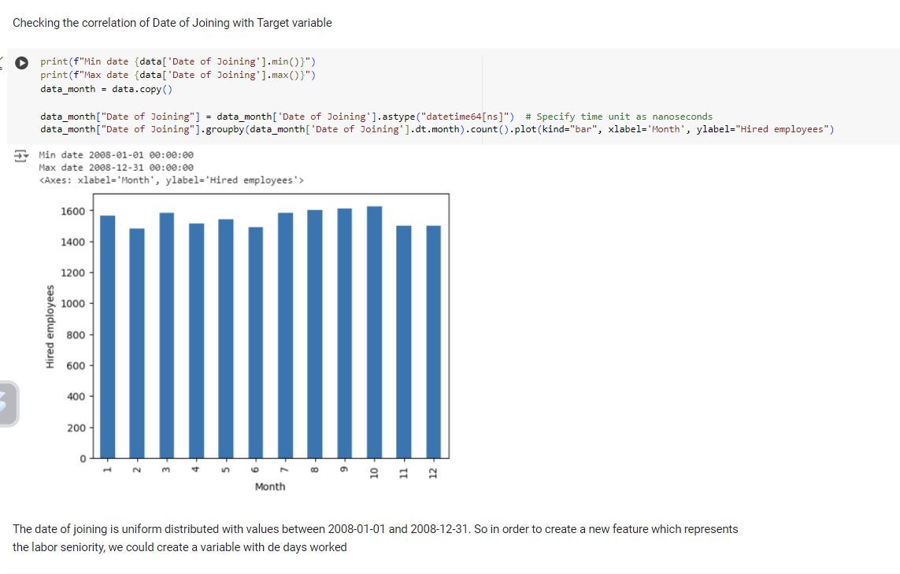

**Number of employees hired each month**

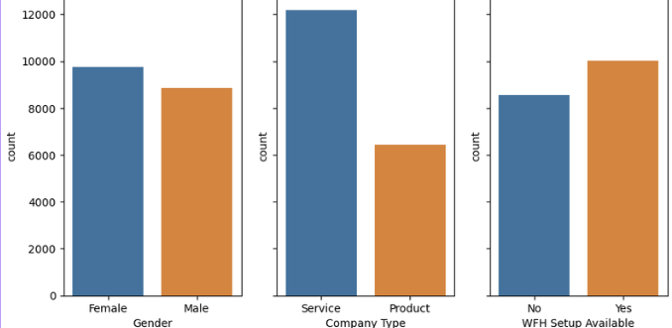

**The observations for each category of all variables are evenly distributed, except for the "Company_Type" variable, where the number of service jobs is nearly double that of product jobs.**

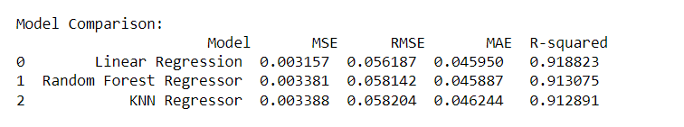

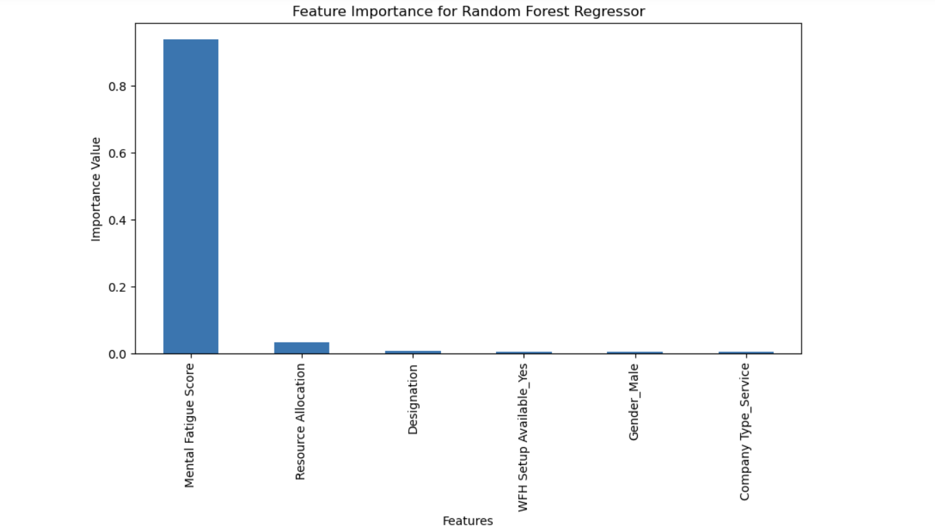

**Final Result**

